**Smart Kitchen using IBM Cloud**

**Project done by: Yanamala Supriya**

**Introduction:**

***Overview:***

**Internet of Things (IOT)** is one of the booming-field in future. Recent improvements in wireless technology have created a new trend in IOT. It plays a major role in the field of health care. Patients with abnormal health conditions can be remotely monitored by smart health care system that uses biomedical sensors to check patient’s condition and uses internet to inform the concerned. This can be encountered through wearable gadgets that continuously monitor the activity and condition of the elderly people. It can also be used at rural areas or villages where nearby clinics or city hospitals can get the data of their patient’s health condition. So, having a smart system, various parameters such as heart beat, temperature, blood pressure etc can be monitored remotely by the concerned, referral doctor and also for personal health care. By using IOT one can monitor the elders regularly and can alert the concerned to react by a message.

***Purpose:***

By this project one can replace all the regular storage jars with the smart jars which sends an alert when the jar gets empty and when the leakage happens from the gas cylinder the leakage is detected and sends the notification at any time remotely. When the gas leakage is detected the exhaust fans are automatically switched ON. So that, they can take care regarding gas leakage. .

**Literature Survey :**

***Existing problem:***

In Pantry shops/Kitchen when there is any usage of any item, then it may not be possible for a person to check whether all the jars are filled with the particular item. This may be a strain for a person to check all the jars in a kitchen or in a pantry shop. And the main problem occurred in many houses and hotels is Gas Leakage . In order to solve these problems faced by many people, there is a need to develop an atmosphere where there is a need problems can be solved easily and effectively.

***Proposed solution:***

By using IOT, we can develop an application which shows the quantity present in the jars and exhaust fans should be automatically switched ON, when the gas leakage is detected from cylinder. It is the “Smart Kitchen System”. In this, the different parameters are measured by sensors in wearable gadgets and these data is sent to the cloud. We can check the quantities through mobile and web apps. If there is any quantity level is decreased, Gas leakage is detected the person is notified through an alert message. This is very useful for every person as they can notified at any anytime and anywhere.

**Theoretical Analysis:**

***Block diagram:***

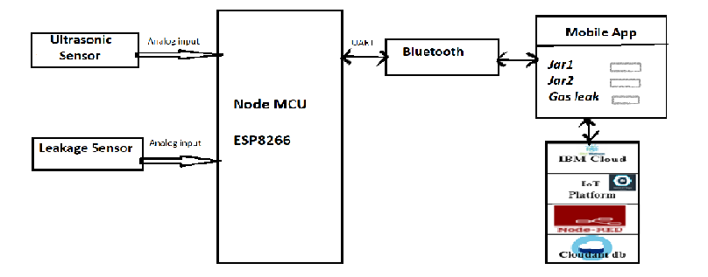

***Hardware / Software designing:***

The hardware and software of this project involve the Node MCU ESP8266 Model, Pulse and Temperature sensors, IBM Cloud, Bluetooth, MIT App Inventor, Node red and Fast2sms. The two sensors are connected to the Node MCU and the values are read by it, processed and then sent to the IBM Cloud services. The data will be displayed in the Mobile application using MIT App Inventor and using Node red the data is displayed in the Web app. Here we use Python language for coding. Fast2sms is used for notification.

**Experimental Investigations:**

The ubiquitous deployment of mobile and sensor devices is creating a new environment called Internet of Things. The performance analysis of IOT applications encounters a lot of challenges such as interaction among a number of different technologies, various usage patterns of smart devices, numerous possible transactions etc. There are several IOT challenges and issues that need to be understood before employing the right solution to a problem that can dynamically vary with the situation. Based on certain critical situations such as IOT Kitchen,health applications, frequent authorization and authentication are necessary and could dynamically vary, resulting in changes to the authorization of IOT devices. To address these issues, automated mutual authentication without human intervention is required.

**Result :**

One can see the details of a quantity level in jar and Gas leakage from anywhere, at any time and it alerts the person.

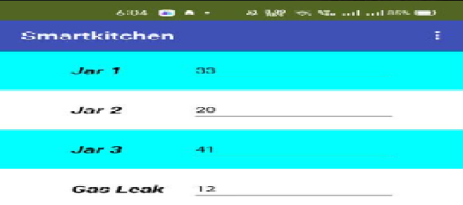

**Advantages & Disadvantages :**

***Advantages of IOT in Smart Kitchen:***

* All-around technological enhancement in Kitchen.
* Bridging the gap between Kitchen and people.
* Can be used in rural areas too.
* Accurate collection .
* Connectivity.
* Easy to operate.
* Supports remote monitoring.
* Accessibility to concerned people from anywhere, at any time.
* Automation.
* Low Cost, High Accuracy.
* The sensor has excellent sensitivity combined with a quick response time.

***Disadvantages of IOT in Smart Kitchen:***

* No prevention of fires possible with kit.
* Applicable only as an indicator/alarming device.
* Its sensitivity depends on Humidity and Temperature.
* It is little sensitive to smoke.
* Network issues while uploading data to cloud.
* Risk of failure, due to bugs in hardware or even power failure can impact the performance of sensors.

**Applications :**

* At Pantry Shops, Kitchen
* At Car Parking
* At Laboratories
* Robotic Sensing
* Hospitals,
* At Textile Industry
* Liquid level control
* People detection System

**Conclusion:**

**Internet of Things** has opened up a world full of possibilities in Kitchen. Thus, the proposed system would gather various details regarding Gas leakage and level of a quantity and it will help the people in any condition. It helps in remote monitoring in Smart Kitchen there by reducing the manual monitoring. It increases the flexibility of the system. It reduces the burden of persons – to check the level and even if leakage is detected.

**Future Scope:**

More and more technological advancements in this field increases more applications for different problems and it increases the scope of reduction of problems. The way the Smart kitchen will be made easy for the people is going to change forever. The digital transformation in smartkitchen is inevitable and it seems to be high time to look beyond the challenges and embark on the journey.

**Bibliography:**

1. Asmita Varma, Prabhakar S and Kayalvizhi Jayavel “Gas Leakage Detection and Smart Alerting and Prediction Using IoT” in 2017 Second International Conference on Computing and Communications Technologies, - vol.6 no.3 pp.327-333, 2017.
2. Kenneth V. Balmes, James Matthew T. Chua, Mary Anne O. De Jesus, and Karen Cristine O. Tan, Argel A. Bandala “Utilization of Sensor Network for Combustible Gas Detection and Monitoring Implemented in House Hold” in 2015 IEEE pp. 978-980, 2015.
3. Apeh S. T, Erameh K. B and Iruansi. U “Design and Development of Kitchen Gas Leakage Detection and Automatic Gas Shut off System” in Journal of Emerging Trends and Applied Sciences (JETEAS), vol.6 pp-222.228 September 2014.